***PAAREES PERFUMES***

***DAVID OFF***

***FOR WOMEN***

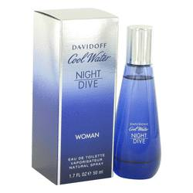

***Cool Water Run Wild***

***Description:***

Cool Water Run Wild by Davidoff Perfume. Introduced in 2019, Cool Water Run Wild is a women's fragrance. It begins with a top note of pomegranate to start with something sweet and juicy. In the middle is jasmine for a feminine and floral element to convey both nature and sophistication. The scent ends with a pistachio base note to provide a creamy and delicious gourmand feel. The clear glass flacon reveals an emerald-like liquid and has a silver topper with the brand's name.  
  
Davidoff was founded by Zino Davidoff, who initially ran a tobacco shop in Geneva, Switzerland from 1936 until his death in 1994. The brand gained international fame once it began producing its own cigars. The Zino Davidoff Group, which focuses on luxury goods, was then founded in 1980 and focuses on watches, accessories, eyewear, leather goods, cognac, coffee, and fragrances. The first fragrance was released in 1984 and Coty holds the fragrance license. The Cool Water fragrance line has been the brand's flagship scent since 1988.